REAL TIME COMMUNICATION SYSTEM POWERED BY AI FOR SPECIALLY ABLED

TEAM LEADER:

SUBREENA BANO

TEAM MEMBERS:

GULSHAN ARA

SUGUNA.S.V

SUREGA.A

DATA VISUALIZATION:

Data visualization is the discipline of trying to understand data by placing it in a visual context so that patterns, trends and correlations that might not otherwise be detected can be exposed.

Python offers multiple great graphing libraries that come packed with lots of different features.

Python provides various libraries that come with different features for visualizing data. All these libraries come with different features and can support various types of graphs. In this tutorial, we will be discussing four such libraries.

* Matplotlib
* Seaborn
* Bokeh
* Plotly

### [**1. Matplotlib**](https://matplotlib.org/)

Matplotlib is a data visualization library and 2-D plotting library of Python It was initially released in 2003 and it is the most popular and widely-used plotting library in the Python community.

### [**2. Plotly**](https://plotly.com/)

Plotly is a free open-source graphing library that can be used to form data visualizations. Plotly (plotly.py) is built on top of the Plotly JavaScript library (plotly.js) and can be used to create web-based data visualizations that can be displayed in Jupyter notebooks or web applications using Dash or saved as individual [HTML](https://www.geeksforgeeks.org/html-tutorials/) files.

### [**3. Seaborn**](https://seaborn.pydata.org/)

Seaborn is a Python data visualization library that is based on Matplotlib and closely integrated with the NumPy and pandas data structures. Seaborn has various dataset-oriented plotting functions that operate on data frames and arrays that have whole datasets within them.

### [**4. Bokeh**](https://bokeh.org/)

Bokeh is a data visualization library that provides detailed graphics with a high level of interactivity across various datasets, whether they are large or small. Bokeh is based on The Grammar of Graphics like ggplot but it is native to Python while ggplot is based on ggplot2 from R.

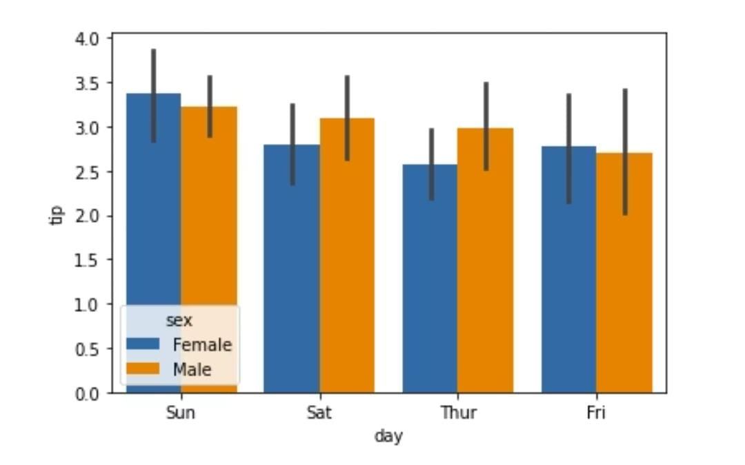

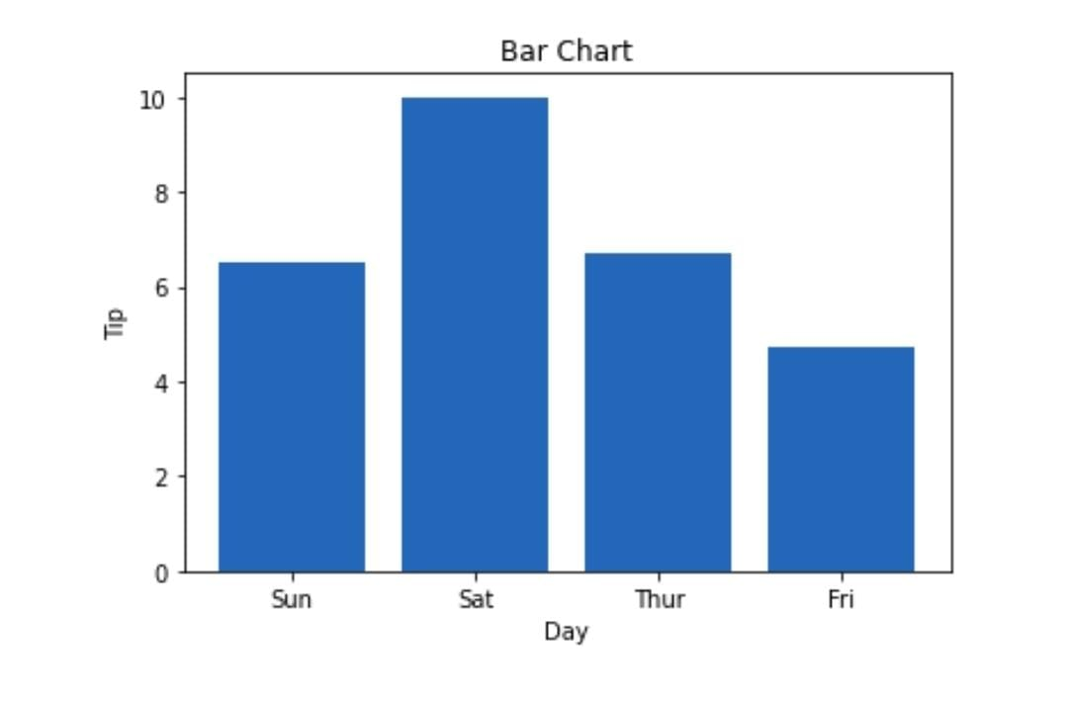

PRE-PROCESSING:

Data Preprocessing is the process of making data suitable for use while training a machine learning model. The dataset initially provided for training might not be in a ready-to-use state, for e.g. it might not be formatted properly, or **may contain missing or null values**.

Solving all these problems using various methods is called Data Preprocessing, using a properly processed dataset while training will not only make life easier for you but also **increase the efficiency and accuracy** of your model.

